

CSA0501-DATABASE MANAGEMENT SYSTEMS

LAB EXPERIMENTS DATE: 08/07/2026

EXPERIMENT 1 -- DDL Commands (CREATE, ALTER, DROP, TRUNCATE, RENAME)

AIM:
To create and manage the database structure for a Student CGPA using Data Definition Language (DDL) commands such as CREATE, ALTER, DROP, TRUNCATE, and RENAME.

PROCEDURE:
- Open MySQL and create the database for the Student CGPA.
- Use the CREATE command to create required tables such as Student, Reg no., Department, number of subjects, number of pass subjects, number of fail subjects and CGPA with suitable attributes and data types.
- Use the ALTER command to add, modify, or remove columns from an existing table.
- Use the RENAME command to change the name of an existing table.
- Use the TRUNCATE command to remove all records from a table while keeping its structure.
- Use the DROP command to permanently delete an unwanted table from the database.
- Use DESC table_name; or SHOW TABLES; after the operations to verify the changes.
- Execute each command and observe the output to ensure that all DDL operations are performed successfully.

PROGRAM:
- CREATE DATABASE

CREATE DATABASE Student_CGPA;
Then select the database:

USE Student_CGPA;

OUTPUT:

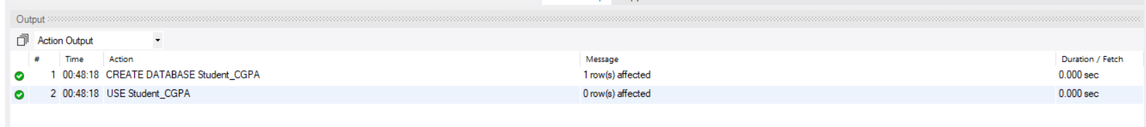

CREATE TABLE

CREATE TABLE student_details (
student_id INT PRIMARY KEY,
student_name VARCHAR(50),
department VARCHAR(50),
semester INT,
cgpa DECIMAL(3,2)
);

OUTPUT:

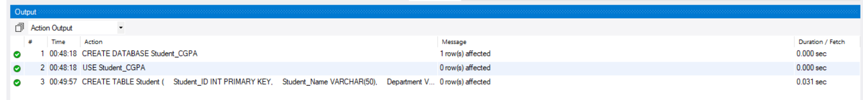

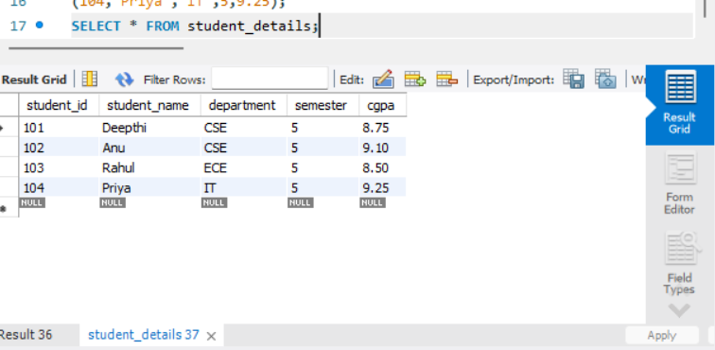

ALTER – ADD COLUMN

Add a new column called E-mail:

ALTER TABLE student_details
ADD email VARCHAR(50);
DESC student_details;

OUTPUT:

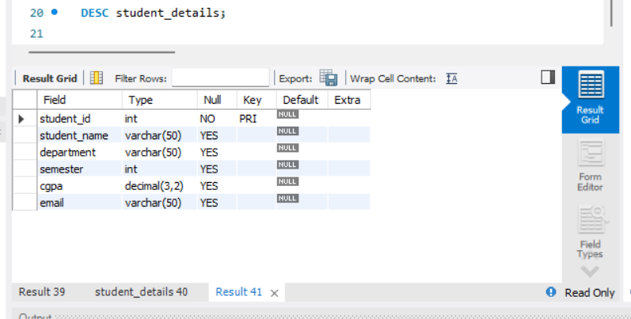

ALTER – MODIFY COLUMN
Change the size of Student_Name:

ALTER TABLE student_details
MODIFY student_name VARCHAR(100);
DESC student_details;



ALTER – DROP COLUMN
Remove the E- MAIL column:

ALTER TABLE student_details
DROP COLUMN email;
DESC student_details;

OUTPUT:

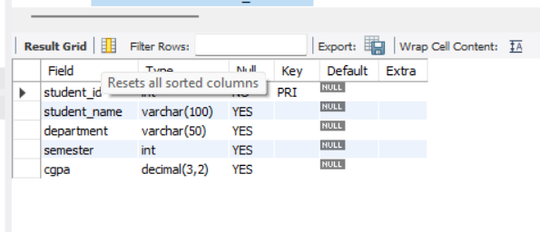

RENAME TABLE
Rename Flight to student_cgpa_details:

ALTER TABLE student_details
RENAME TO student_cgpa_details;
SHOW TABLES;

OUTPUT:

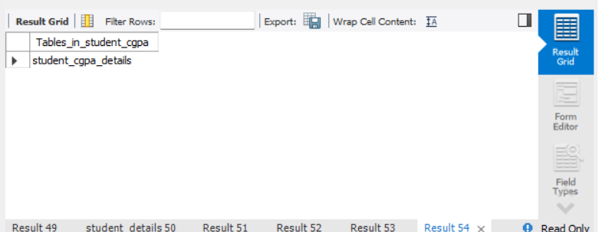

6. TRUNCATE TABLE

TRUNCATE TABLE student_cgpa_details;
Check:

SELECT * FROM student_cgpa_details;

The table will be empty, but the table still exists

OUTPUT:

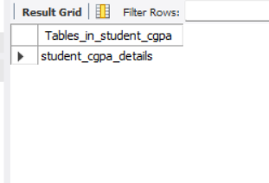

7. DROP TABLE:

DROP TABLE student_cgpa_details;
SHOW TABLES;
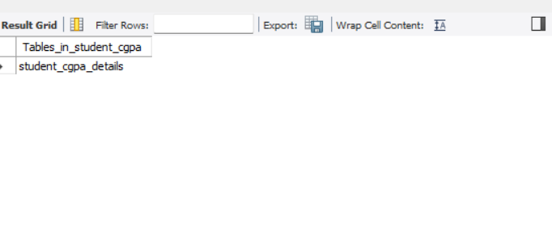

RESULT: Thus the DDL commands executed successfully.

